## Process Concept

* An operating system executes a variety of programs:
* Batch system – jobs
* Time-shared systems – user programs or tasks
* Textbook uses the terms *job* and *process* almost interchangeably

Process – a program in execution; process execution must progress in sequential fashion

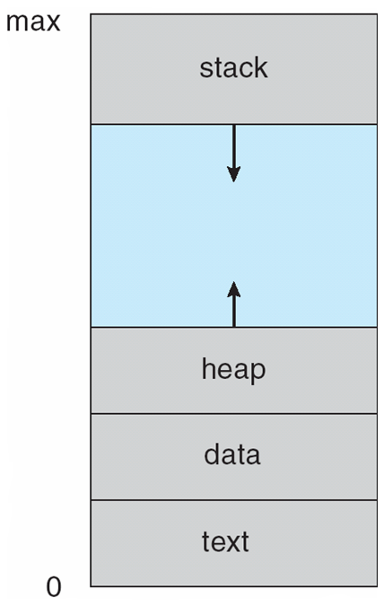A process includes:

* program counter
* stack
* data section

**Process in Memory**

# Process State

As a process executes, it changes *stat*

e

* **new**: The process is being created
* **running**: Instructions are being executed
* **waiting**: The process is waiting for some event to occur
* **ready**: The process is waiting to be assigned to a processor
* **terminated**: The process has finished execution

**Diagram of Process State**

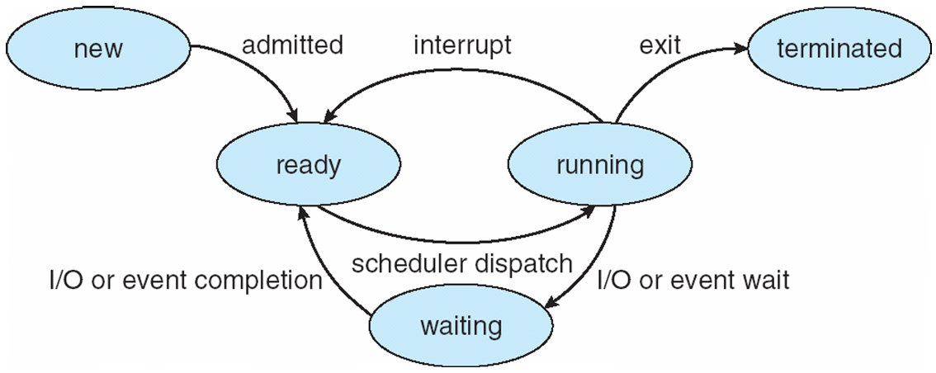

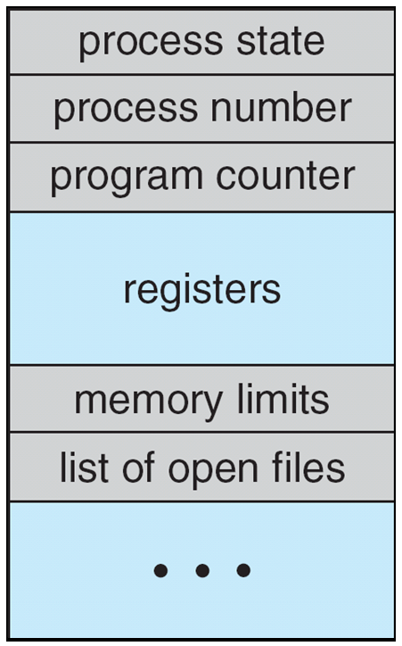**Process Control Block (PCB)**

Information associated with each process

* Process state
* Program counter
* CPU registers
* CPU scheduling information
* Memory-management information
* Accounting information
* I/O status information

**CPU Switch From Process to Process**

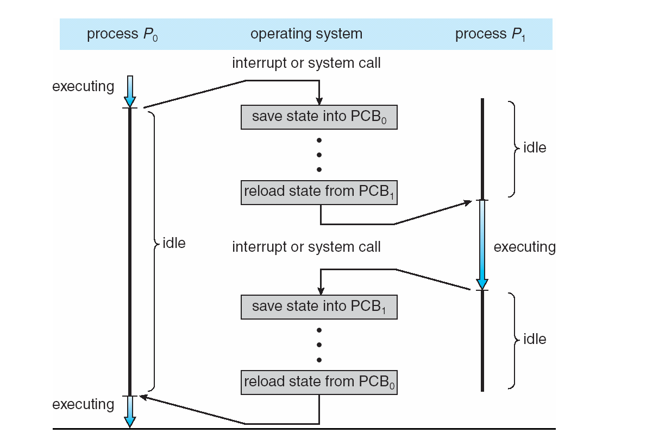

**Process Scheduling Queues**

* **Job queue** – set of all processes in the system
* **Ready queue** – set of all processes residing in main memory, ready and waiting to execute
* **Device queues** – set of processes waiting for an I/O device
* Processes migrate among the various queues

**Ready Queue And Various I/O Device Queues**

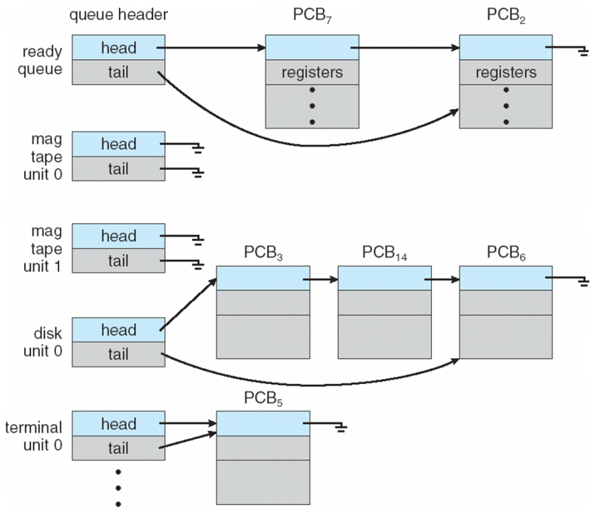

**Representation of Process Scheduling**

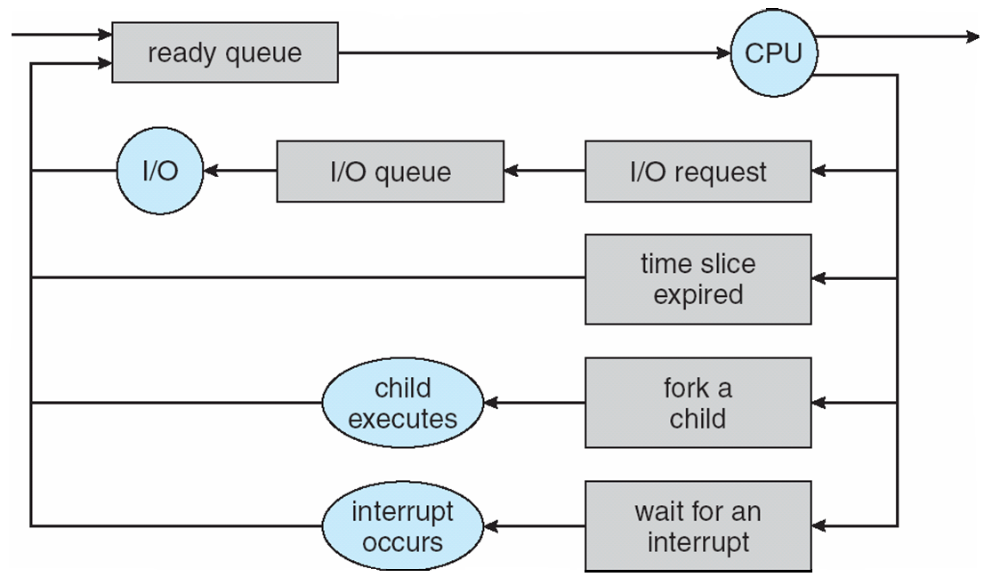

**Schedulers**

* **Long-term scheduler** (or job scheduler) – selects which processes should be brought into the ready queue
* **Short-term scheduler** (or CPU scheduler) – selects which process should be executed next and allocates CPU

**Addition of Medium Term Scheduling**

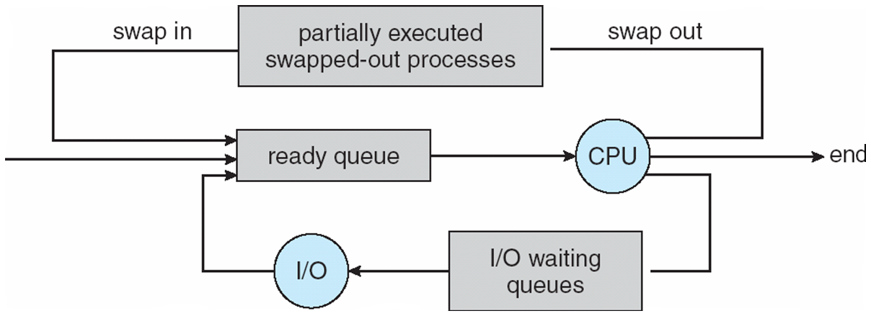

* Short-term scheduler is invoked very frequently (milliseconds) (must be fast)
* Long-term scheduler is invoked very infrequently (seconds, minutes) (may be slow)
* The long-term scheduler controls the *degree of multiprogramming*
* Processes can be described as either:
* **I/O-bound process** – spends more time doing I/O than computations, many short CPU bursts
* **CPU-bound process** – spends more time doing computations; few very long CPU bursts

**Context Switch**

* When CPU switches to another process, the system must save the state of the old process and load the saved state for the new process via a context switch
* Context of a process represented in the PCB
* Context-switch time is overhead; the system does no useful work while switching
* Time dependent on hardware support

**Process Creation**

* **Parent** process create **children** processes, which, in turn create other processes, forming a tree of processes
* Generally, process identified and managed via **a process identifier** (**pid**)
* Resource sharing
* Parent and children share all resources
* Children share subset of parent’s resources
* Parent and child share no resources
* Execution
* Parent and children execute concurrently
* Parent waits until children terminate
* Address space
* Child duplicate of parent
* Child has a program loaded into it
* UNIX examples
* **fork** system call creates new process
* **exec** system call used after a **fork** to replace the process’ memory space with a new program

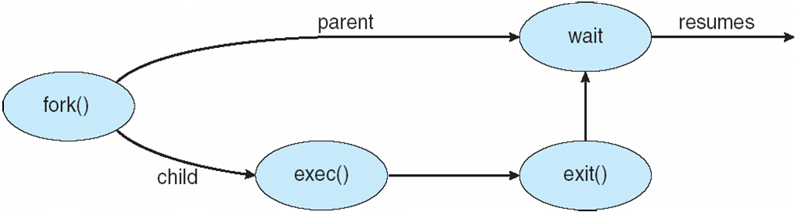**Process Creation**

**C Program Forking Separate Process**

int main()

{

pid_t pid;

/* fork another process */

pid = fork();

if (pid < 0) { /* error occurred */

fprintf(stderr, "Fork Failed");

exit(-1);

}

else if (pid == 0) { /* child process */

execlp("/bin/ls", "ls", NULL);

}

else { /* parent process */

/* parent will wait for the child to complete */

wait (NULL);

printf ("Child Complete");

exit(0);

}

}

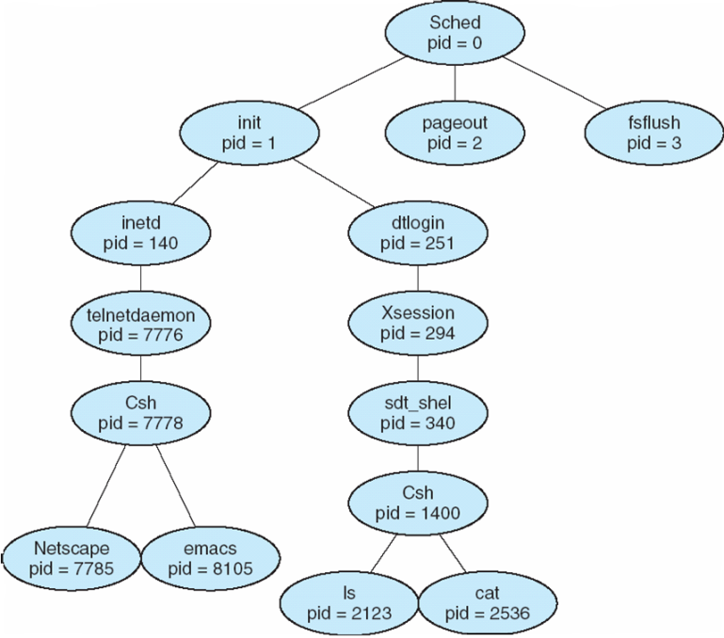**A tree of processes on a typical Solaris**

**Process Termination**

* Process executes last statement and asks the operating system to delete it (**exit**)
* Output data from child to parent (via **wait**)
* Process’ resources are deallocated by operating system
* Parent may terminate execution of children processes (**abort**)
* Child has exceeded allocated resources
* Task assigned to child is no longer required
* If parent is exiting

Some operating system do not allow child to continue if its parent terminates

All children terminated - **cascading termination**

**Interprocess Communication**

* Processes within a system may be **independent** or **cooperating**
* Cooperating process can affect or be affected by other processes, including sharing data
* Reasons for cooperating processes:
* Information sharing
* Computation speedup
* Modularity
* Convenience
* Cooperating processes need **interprocess communication** (**IPC**)
* Two models of IPC
* Shared memory
* Message passing

## Communications Models

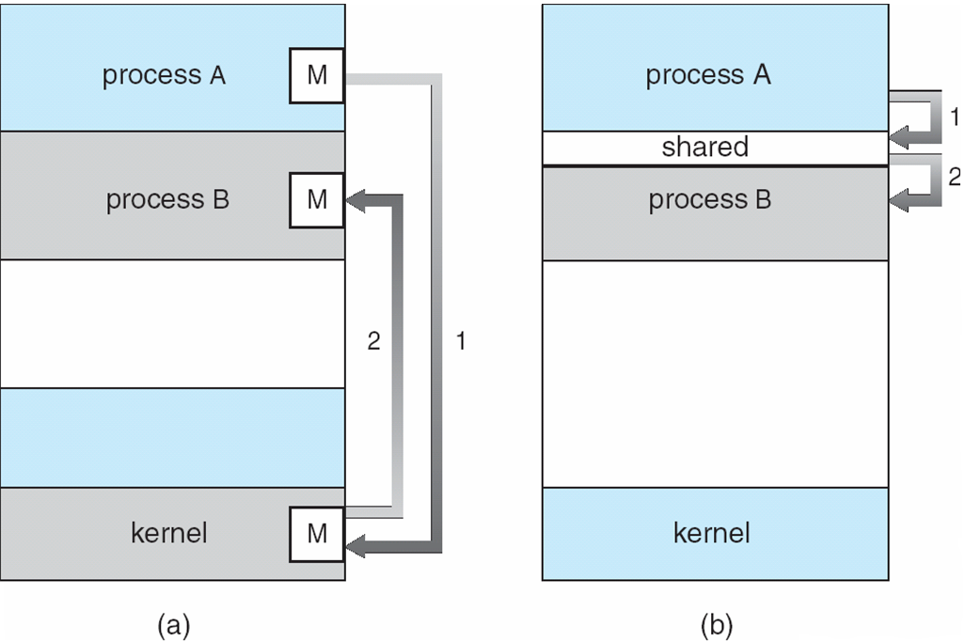

**Cooperating Processes**

* **Independent** process cannot affect or be affected by the execution of another process
* **Cooperating** process can affect or be affected by the execution of another process

Advantages of process cooperation

* Information sharing
* Computation speed-up
* Modularity
* Convenience

**Producer-Consumer Problem**

* Paradigm for cooperating processes, *producer* process produces information that is consumed by a *consumer* process
* *unbounded-buffer* places no practical limit on the size of the buffer
* *bounded-buffer* assumes that there is a fixed buffer size

**Bounded-Buffer – Shared-Memory Solution**

Shared data

#define BUFFER_SIZE 10

typedef struct {

. . .

} item;

item buffer[BUFFER_SIZE];

int in = 0;

int out = 0;

Solution is correct, but can only use BUFFER_SIZE-1 elements

**Bounded-Buffer – Producer**

while (true) {  
 /* Produce an item */

while (((in = (in + 1) % BUFFER SIZE count) == out)

; /* do nothing -- no free buffers */

buffer[in] = item;

in = (in + 1) % BUFFER SIZE;

}

**Bounded Buffer – Consumer**

while (true) {

while (in == out)

; // do nothing -- nothing to consume

// remove an item from the buffer

item = buffer[out];

out = (out + 1) % BUFFER SIZE;

return item;

}

**Interprocess Communication – Message Passing**

* Mechanism for processes to communicate and to synchronize their actions
* Message system – processes communicate with each other without resorting to shared variables
* IPC facility provides two operations:
* **send**(*message*) – message size fixed or variable
* **receive**(*message*)
* If *P* and *Q* wish to communicate, they need to:
* establish a *communication* *link* between them
* exchange messages via send/receive
* Implementation of communication link
* physical (e.g., shared memory, hardware bus)
* logical (e.g., logical properties)

**Direct Communication**

* Processes must name each other explicitly:
* **send** (*P, message*) – send a message to process P
* **receive**(*Q, message*) – receive a message from process Q
* Properties of communication link
* Links are established automatically
* A link is associated with exactly one pair of communicating processes
* Between each pair there exists exactly one link
* The link may be unidirectional, but is usually bi-directional

**Indirect Communication**

* Messages are directed and received from mailboxes (also referred to as ports)
* Each mailbox has a unique id
* Processes can communicate only if they share a mailbox
* Properties of communication link
* Link established only if processes share a common mailbox
* A link may be associated with many processes
* Each pair of processes may share several communication links
* Link may be unidirectional or bi-directional
* Operations
* create a new mailbox
* send and receive messages through mailbox
* destroy a mailbox
* Primitives are defined as:
* **send**(*A, message*) – send a message to mailbox A
* **receive**(*A, message*) – receive a message from mailbox A
* Mailbox sharing
* *P1, P2,* and *P3* share mailbox A
* *P1*, sends; *P2* and *P3* receive
* Who gets the message?
* Solutions
* Allow a link to be associated with at most two processes
* Allow only one process at a time to execute a receive operation
* Allow the system to select arbitrarily the receiver. Sender is notified who the receiver was.

**Synchronization**

* Message passing may be either blocking or non-blocking
* **Blocking** is considered **synchronous**
* **Blocking send** has the sender block until the message is received
* **Blocking receive** has the receiver block until a message is available
* **Non-blocking** is considered **asynchronous**
* **Non-blocking** send has the sender send the message and continue
* **Non-blocking** receive has the receiver receive a valid message or null

**Buffering**

Queue of messages attached to the link; implemented in one of three ways

1. Zero capacity – 0 messages  
Sender must wait for receiver (rendezvous)

2. Bounded capacity – finite length of *n* messages  
Sender must wait if link full

3. Unbounded capacity – infinite length   
Sender never waits

## Examples of IPC Systems - POSIX

* POSIX Shared Memory
* Process first creates shared memory segment
* segment id = shmget(IPC PRIVATE, size, S IRUSR | S IWUSR);
* Process wanting access to that shared memory must attach to it
* shared memory = (char *) shmat(id, NULL, 0);
* Now the process could write to the shared memory
* printf(shared memory, "Writing to shared memory");
* When done a process can detach the shared memory from its address space
* shmdt(shared memory);

**Examples of IPC Systems - Mach**

* Mach communication is message based
* Even system calls are messages
* Each task gets two mailboxes at creation- Kernel and Notify
* Only three system calls needed for message transfer
* msg_send(), msg_receive(), msg_rpc()
* Mailboxes needed for commuication, created via
* port_allocate()

**Examples of IPC Systems – Windows XP**

* Message-passing centric via local procedure call (LPC) facility
* Only works between processes on the same system
* Uses ports (like mailboxes) to establish and maintain communication channels
* Communication works as follows:

The client opens a handle to the subsystem’s connection port object

The client sends a connection request

The server creates two private communication ports and returns the handle to one of them to the client

The client and server use the corresponding port handle to send messages or callbacks and to listen for replies

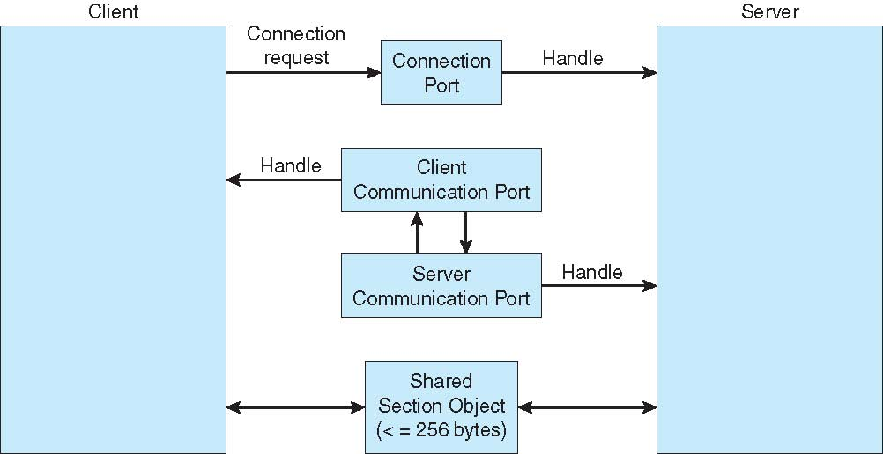**Local Procedure Calls in Windows XP**

**Communications in Client-Server Systems**

* Sockets
* Remote Procedure Calls
* Remote Method Invocation (Java)

**Sockets**

* A socket is defined as an *endpoint for communication*
* Concatenation of IP address and port
* The socket **161.25.19.8:1625** refers to port **1625** on host **161.25.19.8**
* Communication consists between a pair of sockets

**Socket Communication**

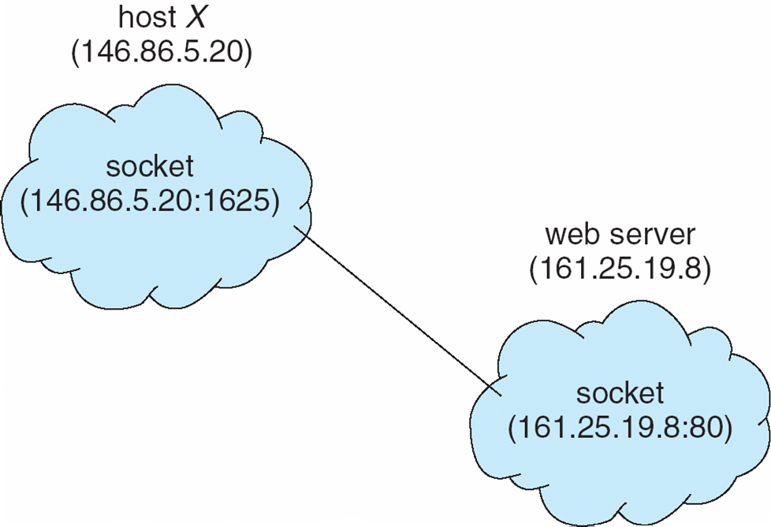

## Remote Procedure Calls

* Remote procedure call (RPC) abstracts procedure calls between processes on networked systems
* **Stubs** – client-side proxy for the actual procedure on the server
* The client-side stub locates the server and *marshalls* the parameters
* The server-side stub receives this message, unpacks the marshalled parameters, and peforms the procedure on the server

**Execution of RPC**

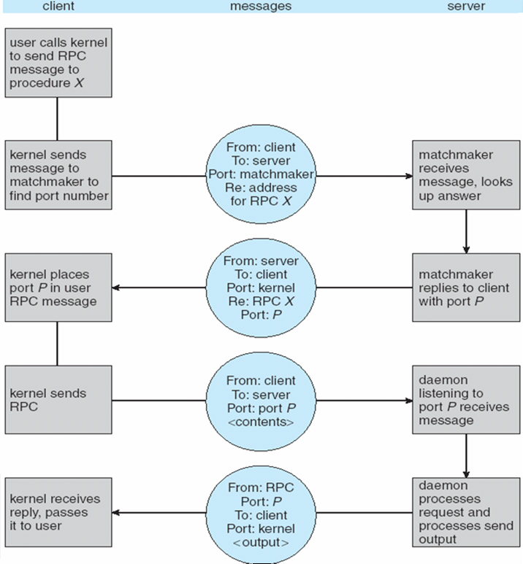

**Remote Method Invocation**

* Remote Method Invocation (RMI) is a Java mechanism similar to RPCs
* RMI allows a Java program on one machine to invoke a method on a remote object

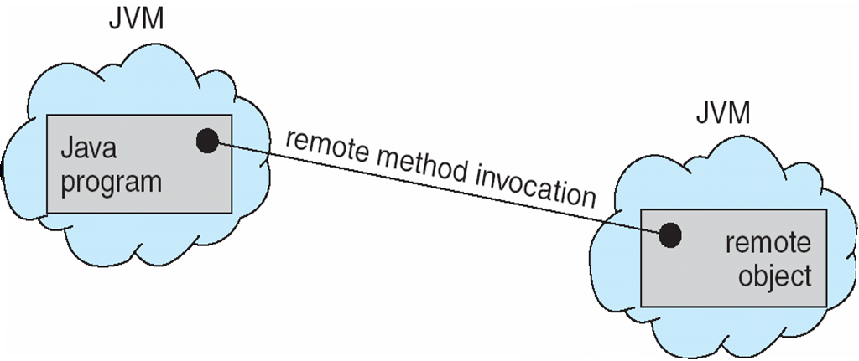

**Marshalling Parameters**

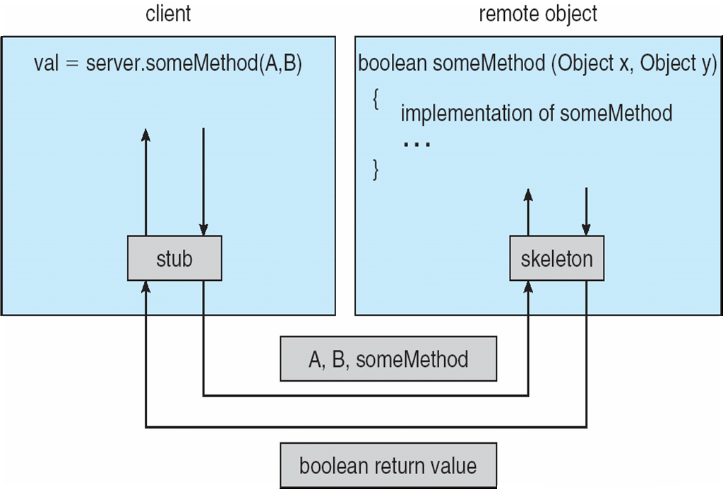

**Threads**

* To introduce the notion of a thread — a fundamental unit of CPU utilization that forms the basis of multithreaded computer systems
* To discuss the APIs for the Pthreads, Win32, and Java thread libraries
* To examine issues related to multithreaded programming

## Single and Multithreaded Processes

**Benefits**

* Responsiveness
* Resource Sharing
* Economy
* Scalability

**Multicore Programming**

Multicore systems putting pressure on programmers, challenges include

* **Dividing activities**
* **Balance**
* **Data splitting**
* **Data dependency**
* **Testing and debugging**

## Multithreaded Server Architecture

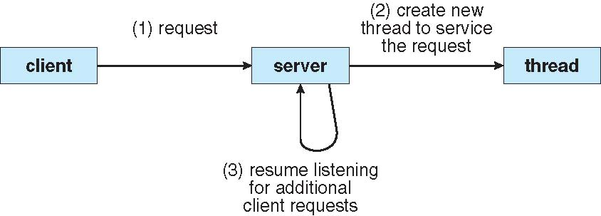

**Concurrent Execution on a Single-core System**

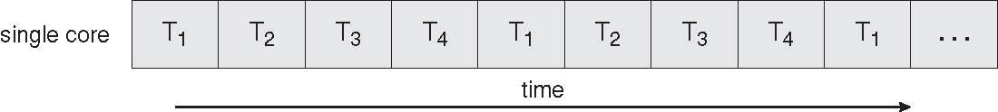

**Parallel Execution on a Multicore System**

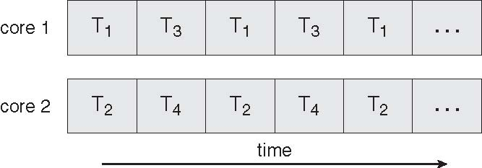

**User Threads**

* Thread management done by user-level threads library
* nThree primary thread libraries:
* POSIX Pthreads
* l Win32 threads
* Java threads

## Kernel Threads

Supported by the Kernel

Examples

* Windows XP/2000
* Solaris
* Linux
* Tru64 UNIX
* Mac OS X

**Multithreading Models**

* Many-to-One
* One-to-One

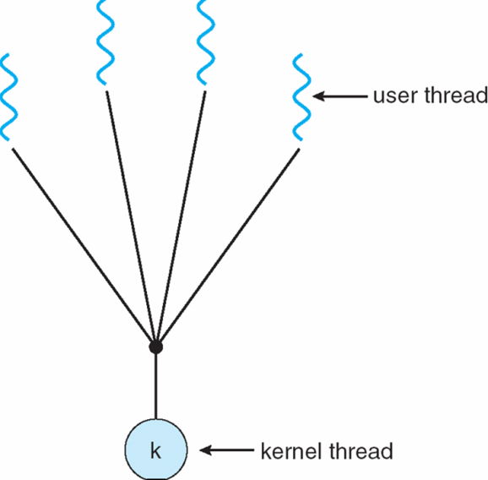

* Many-to-Many

## Many-to-One

Many user-level threads mapped to single kernel thread

Examples:

* Solaris Green Threads
* GNU Portable Threads

**One-to-One**

Each user-level thread maps to kernel thread

Examples

Windows NT/XP/2000

Linux

Solaris 9 and later

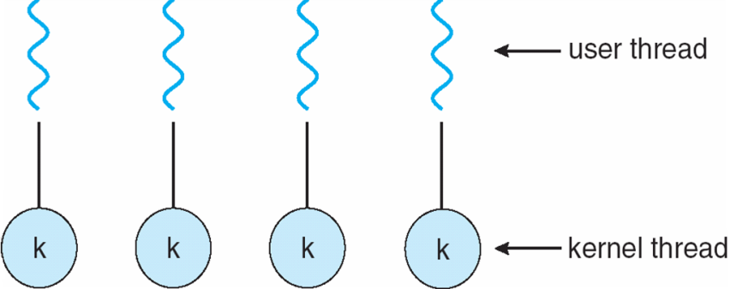

**Many-to-Many Model**

* Allows many user level threads to be mapped to many kernel threads
* Allows the operating system to create a sufficient number of kernel threads
* Solaris prior to version 9

Windows NT/2000 with the *ThreadFiber* package

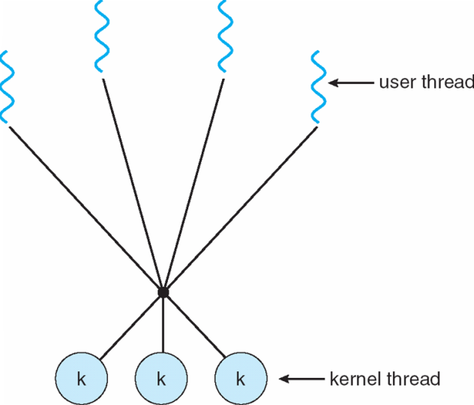

## Two-level Model

Similar to M:M, except that it allows a user thread to be **bound** to kernel thread

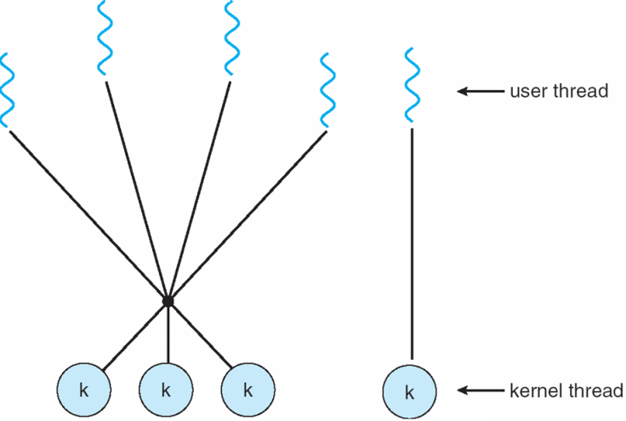Examples

* IRIX
* HP-UX
* Tru64 UNIX
* Solaris 8 and earlier

**Thread Libraries**

* Thread library provides programmer with API for creating and managing threads
* Two primary ways of implementing
* Library entirely in user space
* Kernel-level library supported by the OS

**Pthreads**

* May be provided either as user-level or kernel-level
* A POSIX standard (IEEE 1003.1c) API for thread creation and synchronization
* API specifies behavior of the thread library, implementation is up to development of the library
* Common in UNIX operating systems (Solaris, Linux, Mac OS X)

**Java Threads**

* Java threads are managed by the JVM
* Typically implemented using the threads model provided by underlying OS
* Java threads may be created by:
* lExtending Thread class
* Implementing the Runnable interface

## Threading Issues

* Semantics of **fork()** and **exec()** system calls
* Thread cancellation of target thread
* Asynchronous or deferred
* Signal handling
* Thread pools
* Thread-specific data
* Scheduler activations

**Thread Cancellation**

* Terminating a thread before it has finished
* Two general approaches:
* **Asynchronous cancellation** terminates the target thread immediately
* **Deferred cancellation** allows the target thread to periodically check if it should be cancelled

## Signal Handling

* Signals are used in UNIX systems to notify a process that a particular event has occurred
* A signal handler is used to process signals
* 1.Signal is generated by particular event
* 2.Signal is delivered to a process
* 3.Signal is handled
* Options:
* Deliver the signal to the thread to which the signal applies
* Deliver the signal to every thread in the process
* Deliver the signal to certain threads in the process
* Assign a specific threa to receive all signals for the process

**Thread Pools**

* Create a number of threads in a pool where they await work
* Advantages:
* Usually slightly faster to service a request with an existing thread than create a new thread
* Allows the number of threads in the application(s) to be bound to the size of the pool

**Thread Specific Data**

* Allows each thread to have its own copy of data
* Useful when you do not have control over the thread creation process (i.e., when using a thread pool)

## Scheduler Activations

* Both M:M and Two-level models require communication to maintain the appropriate number of kernel threads allocated to the application
* Scheduler activations provide upcalls - a communication mechanism from the kernel to the thread library
* This communication allows an application to maintain the correct number kernel threads

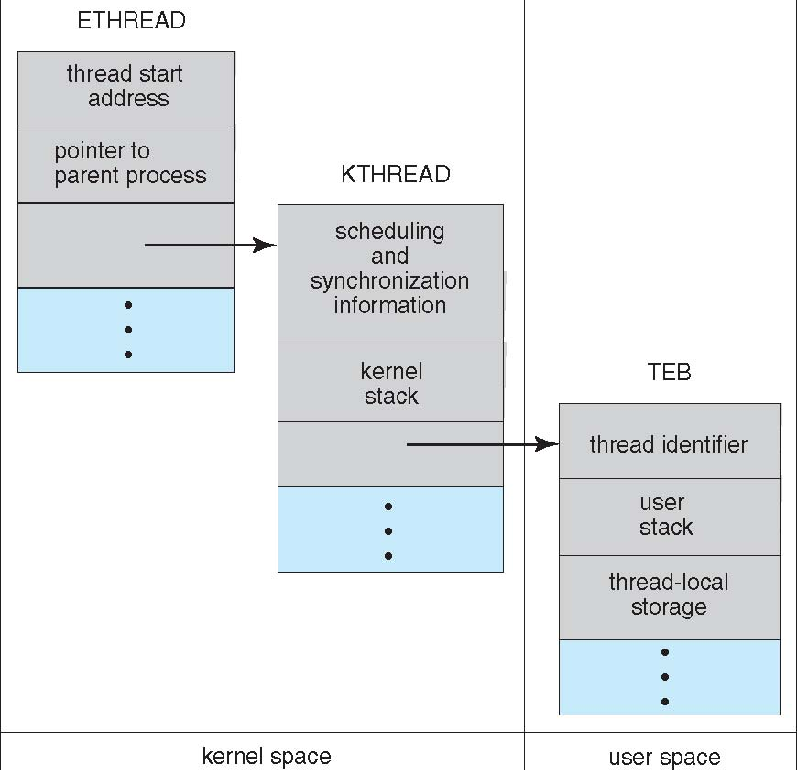**Windows XP Threads**

Implements the one-to-one mapping, kernel-level

* Each thread contains
* A thread id
* Register set
* Separate user and kernel stacks
* Private data storage area
* The register set, stacks, and private storage area are known as the context of the threads
* The primary data structures of a thread include:
* ETHREAD (executive thread block)
* KTHREAD (kernel thread block)
* TEB (thread environment block)

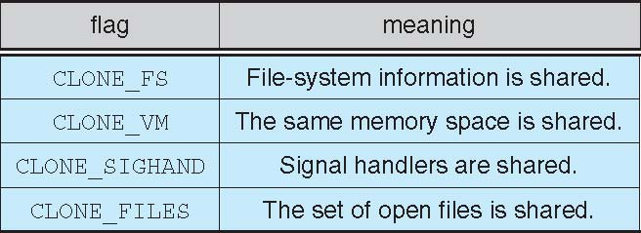**Linux Threads**

* Linux refers to them as *tasks* rather than *threads*
* Thread creation is done through **clone()** system call
* **clone()** allows a child task to share the address space of the parent task (process)

**CPU Scheduling**

* To introduce CPU scheduling, which is the basis for multiprogrammed operating systems
* To describe various CPU-scheduling algorithms
* To discuss evaluation criteria for selecting a CPU-scheduling algorithm for a particular system
* Maximum CPU utilization obtained with multiprogramming
* CPU–I/O Burst Cycle – Process execution consists of a *cycle* of CPU execution and I/O wait
* **CPU burst** distribution

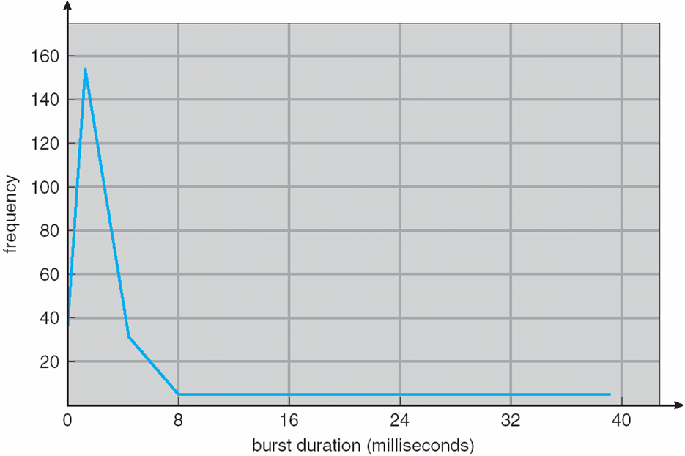**Histogram of CPU-burst Times**

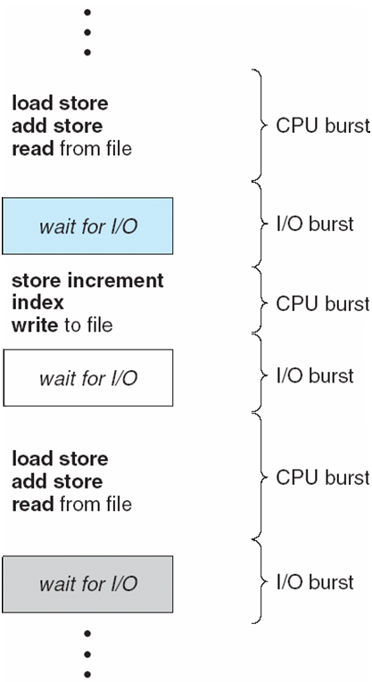**Alternating Sequence of CPU And I/O Bursts**

**CPU Scheduler**

Selects from among the processes in memory that are ready to execute, and allocates the CPU to one of them

CPU scheduling decisions may take place when a process:

1. Switches from running to waiting state

2. Switches from running to ready state

3. Switches from waiting to ready

4. Terminates

Scheduling under 1 and 4 is **nonpreemptive**

All other scheduling is **preemptive**

**Dispatcher**

* Dispatcher module gives control of the CPU to the process selected by the short-term scheduler; this involves:
* switching context
* switching to user mode
* jumping to the proper location in the user program to restart that program
* **Dispatch latency** – time it takes for the dispatcher to stop one process and start another running

**Scheduling Criteria**

* **CPU utilization** – keep the CPU as busy as possible
* **Throughput** – # of processes that complete their execution per time unit
* **Turnaround time** – amount of time to execute a particular process
* **Waiting time** – amount of time a process has been waiting in the ready queue
* **Response time** – amount of time it takes from when a request was submitted until the first response is produced, not output (for time-sharing environment)
* Max CPU utilization
* Max throughput
* Min turnaround time
* Min waiting time
* Min response time

**First-Come, First-Served (FCFS) Scheduling**

Process Burst Time

*P1* 24

*P2* 3

*P3* 3

Suppose that the processes arrive in the order: *P1* , *P2* , *P3*The Gantt Chart for the schedule is:

P1

P2

P3

24

27

30

0

Waiting time for *P1* = 0; *P2* = 24; *P3* = 27

Average waiting time: (0 + 24 + 27)/3 = 17

Suppose that the processes arrive in the order

*P2* , *P3* , *P1*

The Gantt chart for the schedule is:

n

n

n

nWaiting time for *P1 =* 6*; P2* = 0*; P3 =* 3

nAverage waiting time: (6 + 0 + 3)/3 = 3

Much better than previous case

*Convoy effect* short process behind long process

P1

P3

P2

6

3

30

0

**Shortest-Job-First (SJF) Scheduling**

* Associate with each process the length of its next CPU burst. Use these lengths to schedule the process with the shortest time
* SJF is optimal – gives minimum average waiting time for a given set of processes

The difficulty is knowing

Process Arrival Time Burst Time

*P1* 0.0 6

*P2* 2.0 8

*P3* 4.0 7

*P4* 5.0 3

SJF scheduling chart

average waiting time = (3 + 16 + 9 + 0) / 4 = 7

the length of the next CPU request

P4

P3

P1

3

16

0

9

P2

24



**Determining Length of Next CPU Burst**

* Can only estimate the length
* Can be done by using the length of previous CPU bursts, using exponential averaging

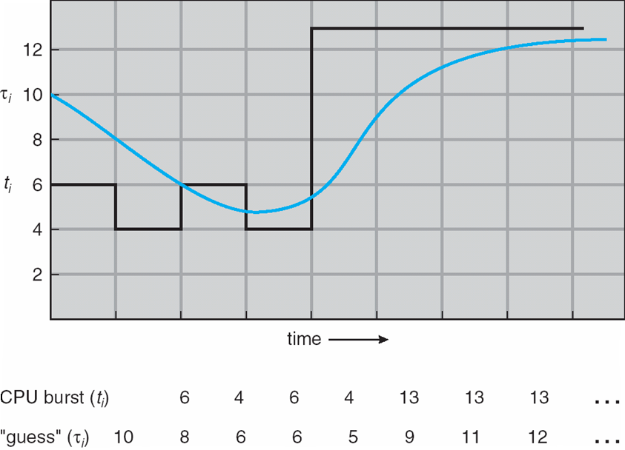**Prediction of the Length of the Next CPU Burst**

## Examples of Exponential Averaging

=0

n+1 = n

Recent history does not count

=1

n+1 = *t*n

Only the actual last CPU burst counts

If we expand the formula, we get:

*n*+1 = t*n*+(1 *- )* *tn* -1+ …

*+(*1 - *)j* *tn* -*j* + …

*+(*1 - *)n* +1 0

Since both and (1 - ) are less than or equal to 1, each successive term has less weight than its predecessor

**Priority Scheduling**

* A priority number (integer) is associated with each process
* The CPU is allocated to the process with the highest priority (smallest integer highest priority)
* Preemptive
* nonpreemptive
* SJF is a priority scheduling where priority is the predicted next CPU burst time
* Problem **Starvation** – low priority processes may never execute
* Solution **Aging** – as time progresses increase the priority of the process

**Round Robin (RR)**

* Each process gets a small unit of CPU time (*time quantum*), usually 10-100 milliseconds. After this time has elapsed, the process is preempted and added to the end of the ready queue.
* If there are *n* processes in the ready queue and the time quantum is *q*, then each process gets 1/*n* of the CPU time in chunks of at most *q* time units at once. No process waits more than (*n*-1)*q* time units.
* Performance
* *q* large FIFO
* *q* small *q* must be large with respect to context switch, otherwise overhead is too high

**Example of RR with Time Quantum = 4**

Process Burst Time

*P1* 24

*P2* 3

*P3* 3

The Gantt chart is:

P1

P2

P3

P1

P1

P1

P1

P1

0

4

7

10

14

18

22

26

30

Typically, higher average turnaround than SJF, but better *response*

**Time Quantum and Context Switch Time**

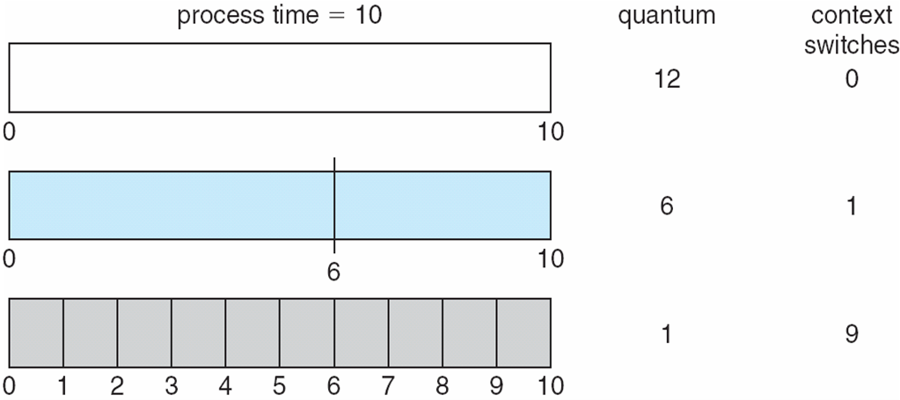

**Turnaround Time Varies With The Time Quantum**

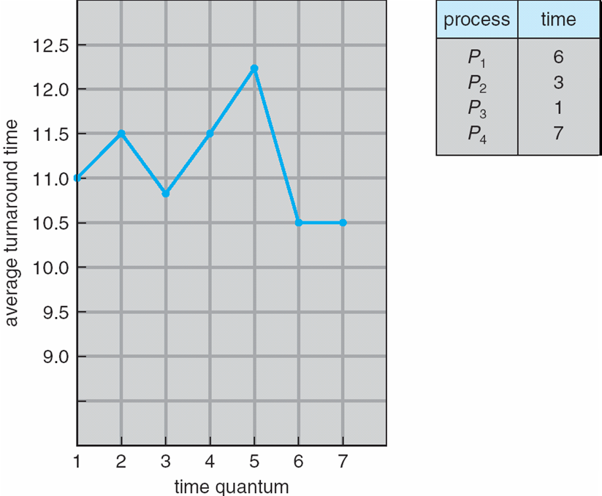

**Multilevel Queue**

* Ready queue is partitioned into separate queues:  
  foreground (interactive)  
  background (batch)
* Each queue has its own scheduling algorithm
* foreground – RR
* background – FCFS
* Scheduling must be done between the queues
* Fixed priority scheduling; (i.e., serve all from foreground then from background). Possibility of starvation.
* Time slice – each queue gets a certain amount of CPU time which it can schedule amongst its processes; i.e., 80% to foreground in RR

20% to background in FCFS

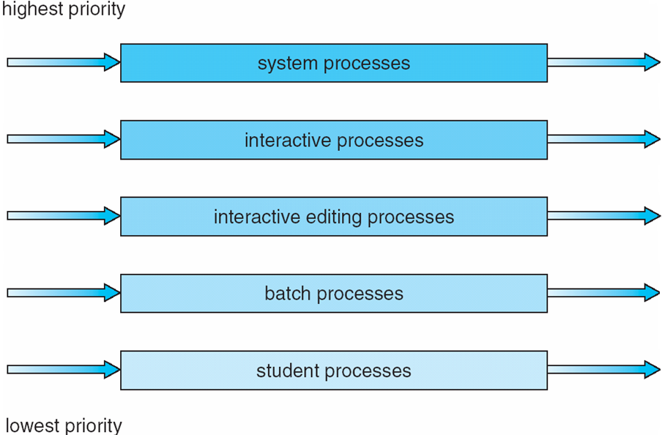**Multilevel Queue Scheduling**

**Multilevel Feedback Queue**

* A process can move between the various queues; aging can be implemented this way
* Multilevel-feedback-queue scheduler defined by the following parameters:
* number of queues
* scheduling algorithms for each queue
* method used to determine when to upgrade a process
* method used to determine when to demote a process

method used to determine which queue a process will enter when that process needs service

**Example of Multilevel Feedback Queue**

Three queues:

* *Q*0 – RR with time quantum 8 milliseconds
* *Q*1 – RR time quantum 16 milliseconds
* *Q*2 – FCFS
* Scheduling
* A new job enters queue *Q0* which is servedFCFS. When it gains CPU, job receives 8 milliseconds. If it does not finish in 8 milliseconds, job is moved to queue *Q*1.
* At *Q*1 job is again served FCFS and receives 16 additional milliseconds. If it still does not complete, it is preempted and moved to queue *Q*2.

**Multilevel Feedback Queues**

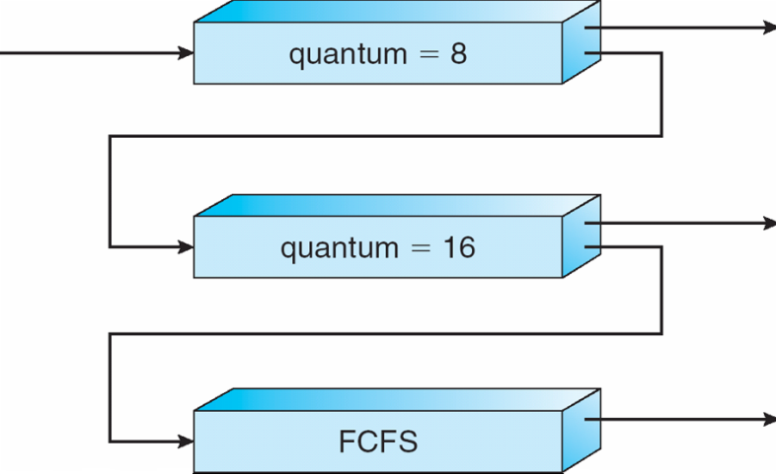

**Thread Scheduling**

* Distinction between user-level and kernel-level threads
* Many-to-one and many-to-many models, thread library schedules user-level threads to run on LWP
* Known as **process-contention scope (PCS)** since scheduling competition is within the process
* Kernel thread scheduled onto available CPU is **system-contention scope (SCS)** – competition among all threads in system

**Pthread Scheduling**

* API allows specifying either PCS or SCS during thread creation
* PTHREAD SCOPE PROCESS schedules threads using PCS scheduling
* PTHREAD SCOPE SYSTEM schedules threads using SCS scheduling.

**Pthread Scheduling API**

#include <pthread.h>

#include <stdio.h>

#define NUM THREADS 5

int main(int argc, char *argv[])

{

int i;

pthread t tid[NUM THREADS];

pthread attr t attr;

/* get the default attributes */

pthread attr init(&attr);

/* set the scheduling algorithm to PROCESS or SYSTEM */

pthread attr setscope(&attr, PTHREAD SCOPE SYSTEM);

/* set the scheduling policy - FIFO, RT, or OTHER */

pthread attr setschedpolicy(&attr, SCHED OTHER);

/* create the threads */

for (i = 0; i < NUM THREADS; i++)

pthread create(&tid[i],&attr,runner,NULL);

/* now join on each thread */

for (i = 0; i < NUM THREADS; i++)

pthread join(tid[i], NULL);

}

/* Each thread will begin control in this function */

void *runner(void *param)

{

printf("I am a thread\n");

pthread exit(0);

}

**Multiple-Processor Scheduling**

* CPU scheduling more complex when multiple CPUs are available
* **Homogeneous processors** within a multiprocessor
* **Asymmetric multiprocessing** – only one processor accesses the system data structures, alleviating the need for data sharing
* **Symmetric multiprocessing (SMP)** – each processor is self-scheduling, all processes in common ready queue, or each has its own private queue of ready processes
* **Processor affinity** – process has affinity for processor on which it is currently running
* **soft affinity**
* **hard affinity**

**NUMA and CPU Scheduling**

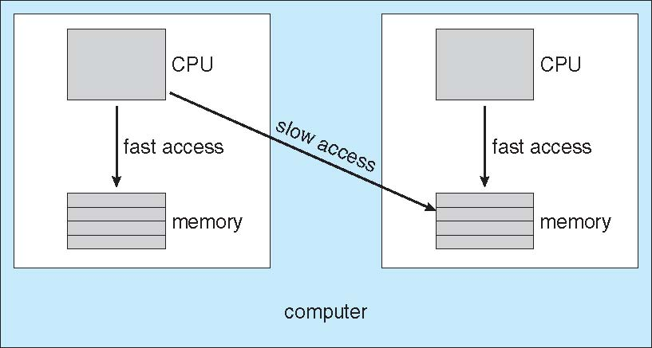

**Multicore Processors**

* Recent trend to place multiple processor cores on same physical chip
* Faster and consume less power
* Multiple threads per core also growing
* Takes advantage of memory stall to make progress on another thread while memory retrieve happens

## 5Multithreaded Multicore System

**Operating System Examples**

* Solaris scheduling
* Windows XP scheduling
* Linux scheduling

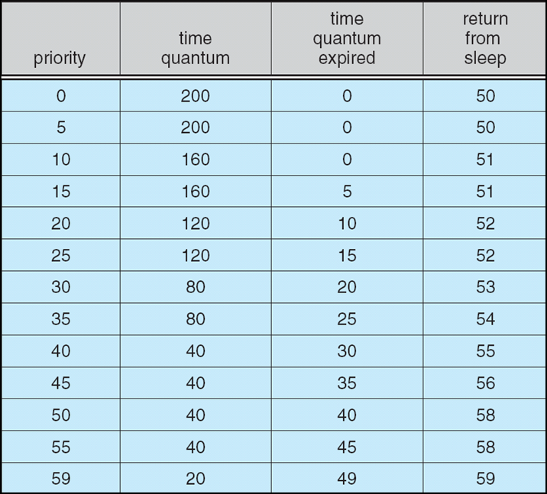**Solaris Dispatch Table**

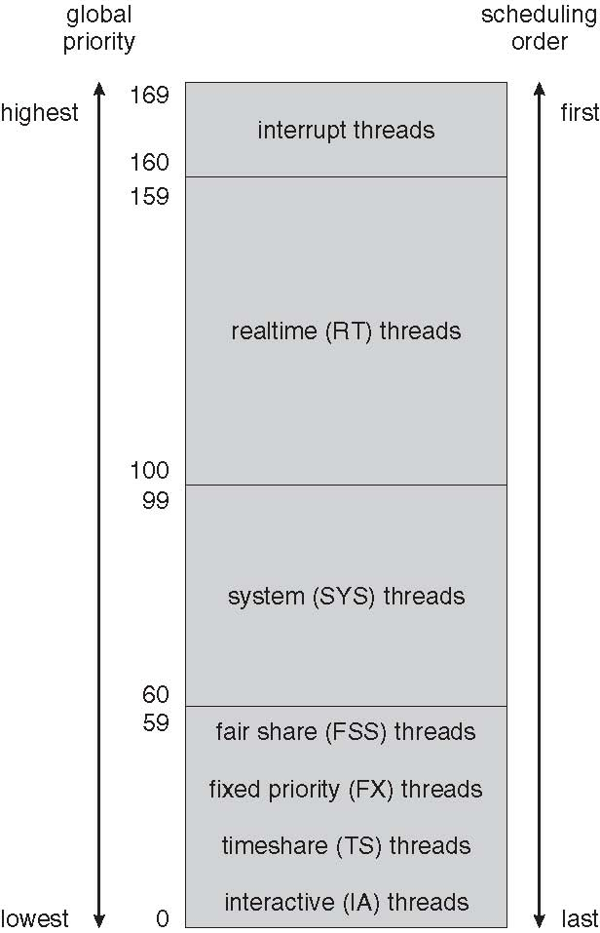**Solaris Scheduling**

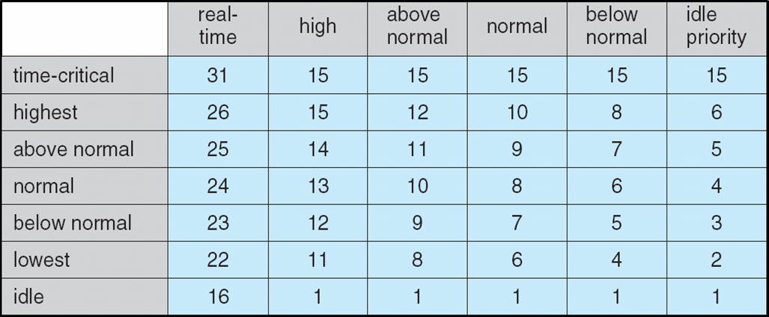**Windows XP Priorities**

**Linux Scheduling**

* Constant order *O*(1) scheduling time
* Two priority ranges: time-sharing and real-time
* **Real-time** range from 0 to 99 and **nice** value from 100 to 140

**Priorities and Time-slice length**

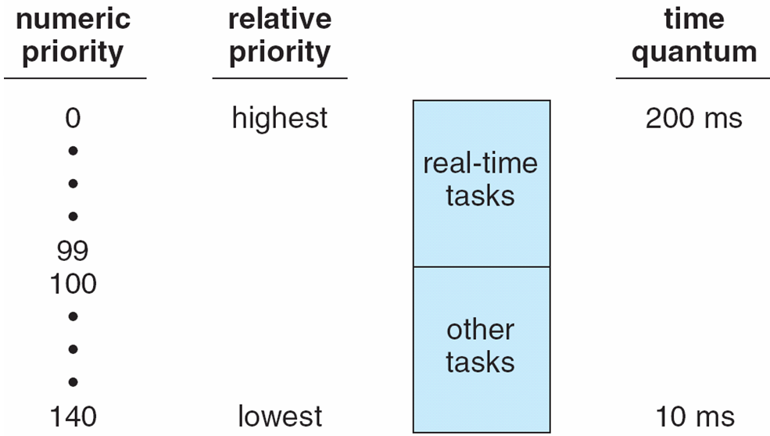

## List of Tasks Indexed According to Priorities

**Algorithm Evaluation**

* Deterministic modeling – takes a particular predetermined workload and defines the performance of each algorithm for that workload
* Queueing models
* 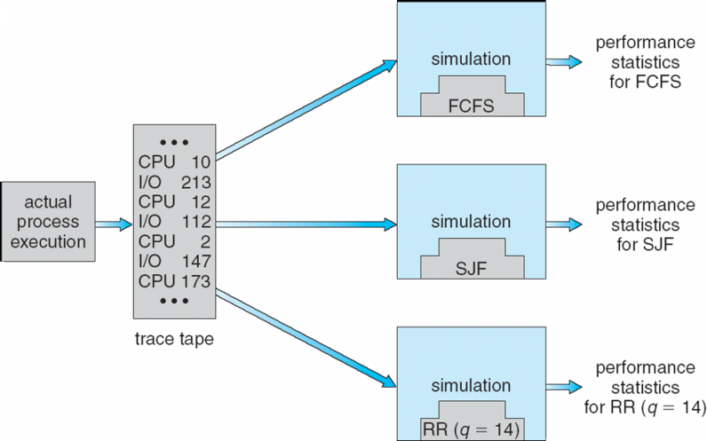Implementation

**Evaluation of CPU schedulers by Simulation**